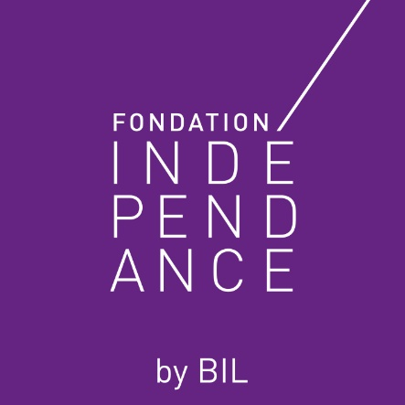

The Fondation Indépendance was established in 1999 by Banque Internationale à Luxembourg. Its aim is to promote art and culture, particularly of a contemporary nature, through its various forms of expression.
The Fondation only participates in one-off projects, with a focus on young creators.
Prospective projects must be high quality, of cultural value and professional in their approach, while a human, educational and social dimension is desirable.
We will not consider any applications of a commercial nature.

You can use this form to outline the purpose of your sponsorship or patronage request. It will then be sent to the Fondation Indépendance to be reviewed by a panel of art and cultural experts. The information you provide will help them to understand your expectations and make a decision to accept or deny your request for funding.

This document is for use by organisations: non-profit organisation, museum, association, artists’ collective, etc.
- Please send the completed document to: fondation_independance@bil.com.
- You may also include any relevant documents relating to your success stories or projects.

The information in this document is provided for information purposes only. We do not guarantee that this information is complete, accurate or up to date. It does not in any way constitute approval of a sponsorship or patronage request.

What kind of organisation are you? (non-profit organisation, association, artists’ collective, etc.)

General information

Name

Trade and Companies Register number

Incorporation date

Recognised and funded as (please indicate the most recent recognition/agreement/subsidy and, where applicable, the ASFT authorisation number)

Contact details

Registered office
Number and street
Postcode
City
Telephone
Email address
Website
Social networks (URL)
Reference sites, e.g. your website, a video, etc. (URL)

Bank details

IBAN
Account holder

Detailed information on your organisation

What are its missions?

Who is it for?

What are its main activities?

Where does it operate?
nationwide
in one/several commune(s)
in one/several region(s)
in other countries
How many members work there?
How many employees work there?
Please enclose the following documents: the articles of association published in the Mémorial and the annual accounts (recent balance sheet)

Contact person

First name
Surname(s)
Title
Role in the organisation
Telephone
Email address

Project description

- Name of art project

Type of art project (delete as appropriate)

Cinema, Music, Photography, Theatre, Dance, Literature, Design, Fashion Design, Contemporary Art, Modern Art, Digital Art, Culinary Art
Other

Type of project (delete as appropriate)

Installation, Performance, Show, Exhibition, Lecture, Concert, Festival, Conference, Multimedia, Screening, Competition, Research, Forum, Workshop, Party
Other

Schedule

When is your project scheduled to begin?
When is the scheduled end date?
Please provide dates for the main phases of your project

Please specify the location where your project will be presented/exhibited

Financial information

Please provide detailed information about the budget required for your project (own funds, third party subsidies, personal contribution, aid granted by other public or private bodies)

Total budget (in EUR) / double click to open the excel file
Amount of financial aid requested from Fondation Indépendance (in EUR)

To which expenditure item would you like to allocate the support from Fondation Indépendance?

Why does your project need this financial aid?

Communication

How will you let people know about your project?

How will this patronage/sponsorship benefit the Fondation Indépendance (e.g. image, reputation, population/demographic affected, mention in communications, etc.)

Previous artistic or cultural projects

If you wish, please describe some of your previous activities.

